Real Time and

Embedded Systems:

Project 5

To measure the distance between the rear

bumper of a car and any objects behind the vehicle while

parking.

**Harshdeep Singh Chawla**

[hxc3427@rit.edu](mailto:hxc3427@rit.edu)

**Karishma Ganesh Reddy**

[kgr2269@rit.edu](mailto:kgr2269@rit.edu)

# Abstract

The objective of this project is to design and implement an embedded, stand-alone QNX Neutrino program to measure the distance between the rear bumper of a car and any objects behind the vehicle while parking.

# Analysis/Design

Driver:When the vehicle is placed into reverse, the parking sensor is activated,

providing a continuous stream of data on the distance of any objects behind the vehicle.

Car:The parking sensor is mounted on the rear bumper of the car.

Parking Sensor:When activated, the parking sensor measures the distance between

itself (as located on the rear bumper) and any objects within its field of view. The

distance is reported to the driver on a continuous basis.

### Design Constraints:

* + - * The distance is measured at a rate of 10 times per second.
      * The results of the measurement is displayed on the console so that the value does not scroll.
      * The measured results are rounded to the nearest inch and displayed as integers values only.
      * Out-of-range measurements are represented as a flashing asterisk.
      * The measuring process is started when the user selects a key, and ended when the user selects another.
      * After measurements are ended, display the maximum and minimum distances measured.
      * In your report, include test cases and explicit results indicating the practical range of your ultrasound sensor.

The approach used in the completion of this project is as follows:

* Understand the components and functionality of the Purple Box.
* Understand the functionality of the Sensor.
* Determine method of calculating the distance.
* Write and debug program.

# Areas of Focus:

## Harshdeep:

* Hardware Configuration.
* Report work.

## Karishma:

* Design and implementation of code on QNX neutrino.
* Creation of Test Plan.

# Hardware

## Sensor Used

### INTRODUCTION

The ​HC­SR04ultrasonic sensor uses sonar to determine distance to an object like bats or

dolphins do. It offers excellent non­contact range detection with high accuracy and stable

readings in an easy­to­use package. From 2cm to 400 cm or 1” to 13 feet. It operation is not

affected by sunlight or black material like Sharp rangefinders are (although acoustically soft

materials like cloth can be difficult to detect). It comes complete with ultrasonic transmitter

and receiver module.

#### Features:

* Power Supply: +5V DC
* Quiescent Current: <2mA
* Working Current: 15mA
* Effectual Angle: <15°
* Ranging Distance: 2cm – 400 cm/1" ­ 13ft
* Resolution: 0.3 cm
* Measuring Angle: 30 degree
* Trigger Input Pulse width: 10uS
* Dimension: 45mm x 20mm x 15mm

2.0 Sensor LAYOUT

* VCC = +5VDC
* Trig = Trigger input of Sensor
* Echo = Echo output of Sensor
* GND = GND

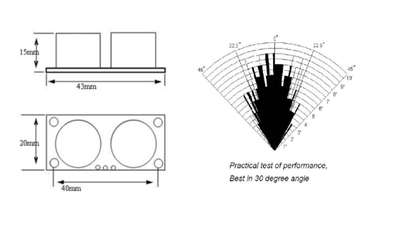

3.0 PRODUCT SPECIFICATION

|  |  |  |  |  |
| --- | --- | --- | --- | --- |
| **Parameter** | **Min** | **Typ.** | **Max** | **Unit** |
| Operating Voltage | 4.50 | 5.0 | 5.5 | V |
| Quiescent Current | 1.5 | 2 | 2.5 | mA |
| Working Current | 10 | 15 | 20 | mA |
| Ultrasonic Frequency | - | 40 | - | kHz |

### 4.0 OPERATION

The timing diagram of ​HC­SR04is shown. To start measurement, Trig of SR04 must receive

a pulse of high (5V) for at least 10us, this will initiate the sensor will transmit out 8 cycle of

ultrasonic burst at 40kHz and wait for the reflected ultrasonic burst. When the sensor detected

ultrasonic from receiver, it will set the Echo pin to high (5V) and delay for a period (width)

which proportion to distance. To obtain the distance, measure the width (Ton) of Echo pin.

* Time = Width of Echo pulse, in uS (micro second)
* Distance in centimeters = Time / 58
* Distance in inches = Time / 148
* Or you can utilize the speed of sound, which is 340m/s

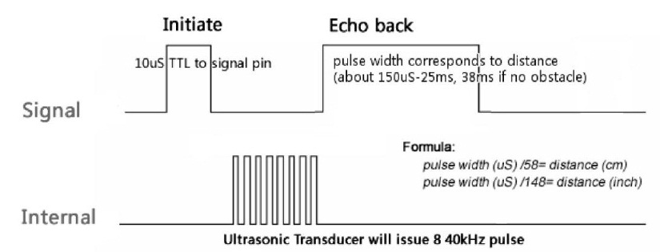

## Micro- Controller

We made use of the ‘Purple box’ which has an Athena microcontroller. Connections to the sensor was made through the

data acquisition (DAQ).

# Test Plan

## Hardware test:

The proper functioning of the sensor was checked using the oscilloscope after making the proper pin connections and providing the trigger pulses.

## Software test:

The software testing consisted of issuing proper trigger signals to the sensor and then noting down the output obtained from the sensor in terms of inches and also obtaining the maximum and minimum distance.

# Flow Chart

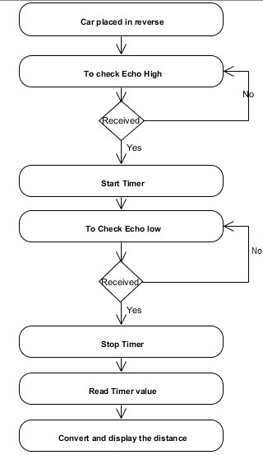

# Lessons Learned

In this project, we learned about the basic features of QNX and how to use it. As it was the first time we have used a Sensor with QNX, there was a pretty steep learning curve. A major challenge was determining the information we needed to know and then finding it within the manuals. However, once an initial general understanding of the hardware was achieved, this process became fairly straightforward. Another challenge encountered was adequately dividing the work and responsibilities. Developing cross discipline skills is important as a student and it later becomes essential when entering industry. After this was achieved, the code was developed and debugged to obtain the proper output. However, the desired results were not obtained, as instead of obtaining accurate values the sensor output showed “out of bounds” every time.

# Output:

